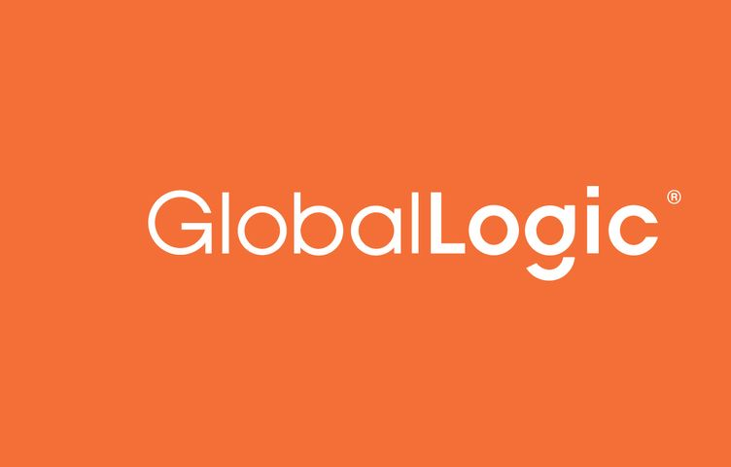

**GL – Muse Project**

**Group – 2**

* **Pooja Miskin**
* **Namrata Singh**
* **S S Sai Gopala Pavan Rutwik Manapragada**

**GL – Muse Project Task – 1**

**Task :** Exploring and Analysing LXP’s

**Sites :** Coursera and Teachable

**To Do :**

1) Features It Supports

2) Try It Out Free Login Compatible

3) What we liked in the Platform

4) What we didn’t liked in the Platform

5) Wow Features

6) Suggestions

7) Types of Assesments and Assignmensts Present.

**Coursera**

**Coursera :**

Coursera Inc. is a U.S.-based massive open online course provider founded in 2012 by Stanford University computer science professors Andrew Ng and Daphne Koller. Coursera works with universities and other organizations to offer online courses, certifications, and degrees in a variety of subjects. In 2021 it was estimated that about 150 universities offered more than 4,000 courses through Coursera.

## Partners :

As of December 2019, the total number of partners is more than 200 across 29 countries. Coursera mainly works with universities and colleges, but also with corporations and governments. University partners include University SaoPaulo in Brazil, University of London in the UK, Indian School of Business of India and many more. Google will consider all of its certificates as the equivalent of a four-year college degree.

Courses :

Coursera courses last approximately four to twelve weeks, with one to two hours of video lectures a week. These courses provide quizzes, weekly exercises, peer-graded and reviewed assignments, an optional Honors assignment, and sometimes a final project or exam to complete the course. Courses are also provided on-demand, in which case users can take their time in completing the course with all of the material available at once. As of May 2015, Coursera offered 104 on-demand courses. They also provide guided projects which are short 2-3 hour projects that can be done at home.

According to 'Coursera Impact Report 2020', the top five most popular courses that people learn from Coursera were contact tracing, digital marketing, project management, Python programming, and social psychology.

Degrees :

As of 2017, Coursera offers complete master's degrees. They first started with a Master's in Innovation and Entrepreneurship (OMIE) from HEC Paris and a Master's of Accounting (iMSA) from the University of Illinois but have moved on to offer a Master of Computer Science in Data Science and Master of Business Administration (iMBA), both from University of Illinois. Also as part of their MBA programs, there are some courses which are offered separately, which are included in the curriculum of specific MBAs when enrolling in classes such as their digital marketing courses.

Professional Certificate :

Google, IBM, Meta and other well-known companies, launched various courses for professional certificates, allowing students to fill the workforce in various sectors, such as data analytics, IT support, digital marketing, UX design, project management, and Data science. According to Google, their courses are equivalent to 4 year degrees. They also offered 100,000 scholarships. Google and its 20+ partners will accept those certificates as 4- year degree equivalent.

Financial :

Coursera's revenues rose from $184 million in 2019 to $294 million in 2020. To date, Coursera has not made a profit. The company lost $66 million in 2020 as it ramped up marketing and advertising.

For the first quarter of 2021, Coursera reported revenue of $88.4 million, up 64% from a year earlier, with a net loss of $18.7 million, or $13.4 million on a non-GAAP basis. Coursera said consumer revenue was $51.9 million, up 61%, while enterprise revenue was $24.5 million, up 63%, and degree programs had revenue of $12 million, up 81%.[[16]](https://en.wikipedia.org/wiki/Coursera" \l "cite_note-:0-16)

For the third quarter of 2021, Coursera reported revenue of $109.9 million, up 33% from $82.7 million a year ago. Gross profit was $67.7 million or 61.6% of revenue. Net loss was $(32.5) million or (29.5)% of revenue.

#### Funding :

The startup raised an initial $16 million funding round backed by Kleiner Perkins Caufield & Byers and New Enterprise Associates. In 2013, GSV led the Series B investment, which totaled $63 million. In 2015, NEA led the Series C round of venture funding, which totaled more than $60 million. In 2017, the company raised $64 million from its existing investors in a Series D round of funding. In 2019, the company raised $103 million in Series E round of funding from the SEEK Group, Future Fund and NEA. The company reached valuation of $1 billion+ in 2019. In July 2020, the company announced it had raised $130 million in Series F funding and updated its valuation to $2.5 billion.

Despite many competetorin the e-learning field Coursera is still able held its ground and is one of the most populare Learning platform. It’s users are in an inclined graph and has a great potential to see huge profits in the comming future.

**Some Wiki Info on Coursera :**

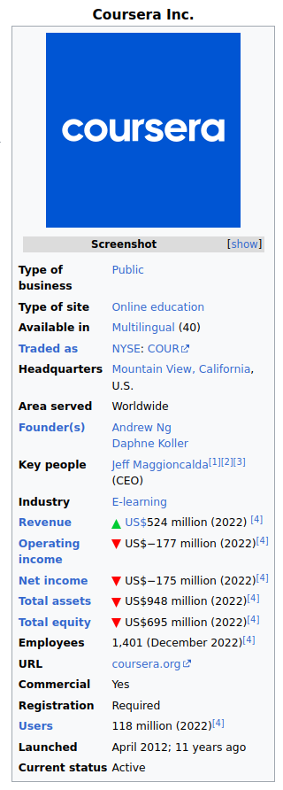

**Task :**

**1) Features It Supports :**

* Practice Quizes
* Login and Signup using Gmail, Facebook
* Self Paces Learnings
* Course Videos and Course Materials
* Graded Programming Assignments with Feedback
* Graded Quizes with Feedback
* Free Courses along with Paid Courses

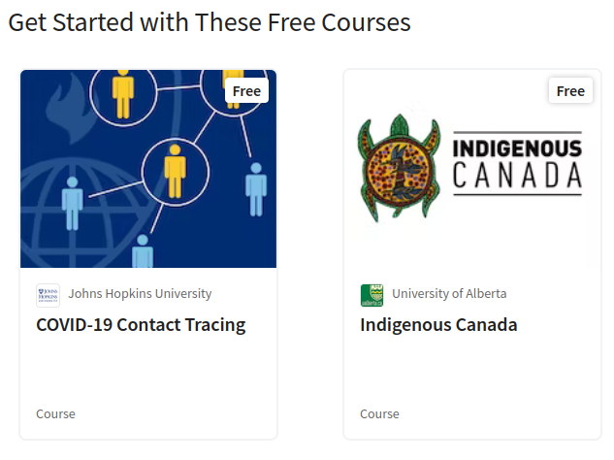

* Degree from various Universities

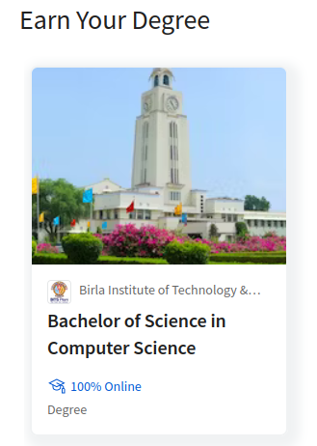

* Certifications

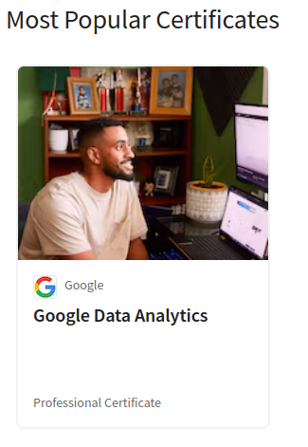

* Coursera Plus Subscription

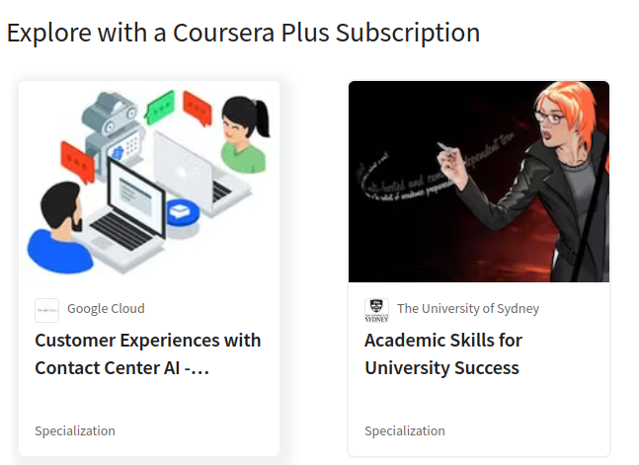

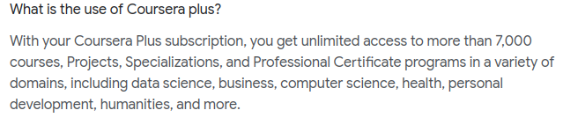

**2) Try it Out Free Login compatible:**

It is free login and compatible, We can signup without paying any amount. We did for User Perspective.



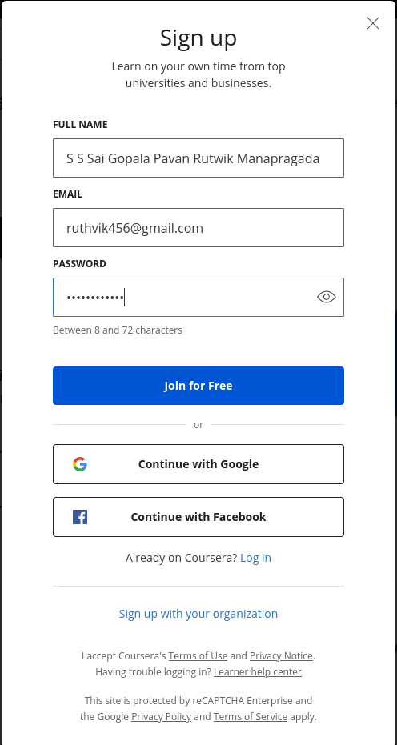



**3) What we liked in the Platform :**

* Based on the Inputs from us like what we do and what we want to 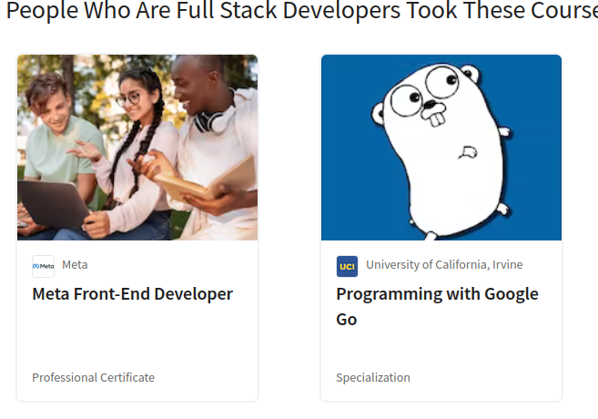do, AI – Based suggestion on the Courses that might interst us.
* Community Section

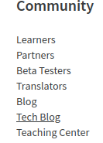

* Great Info to guide the picking of a new Skill

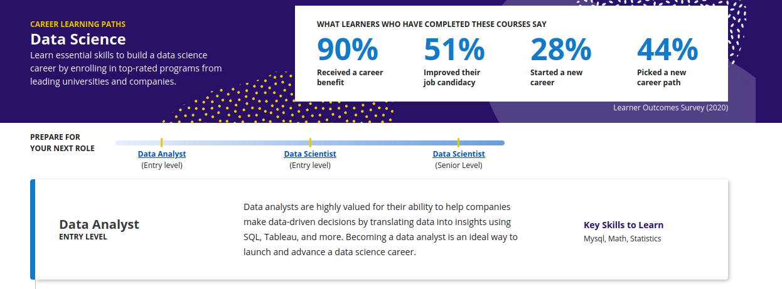

* 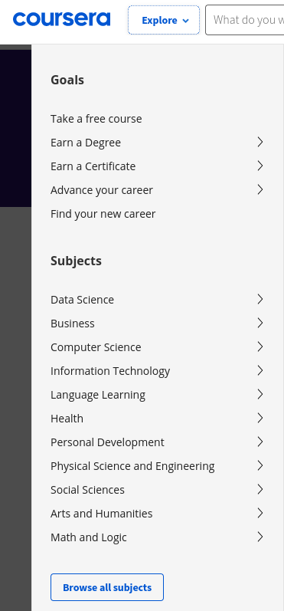Explore Section
* Option to for various users like Individual, University , Goverment etc on top of the UI. Easily Accessible.



* Good UI to navigate to Completed, In progress courses.

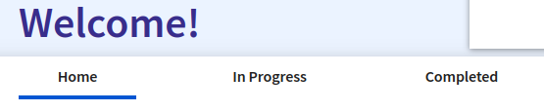

* Simple and Clean User Interface.

**4) What we didn’t liked in the Platform :**

* Frequently ask questions at the bottom of page

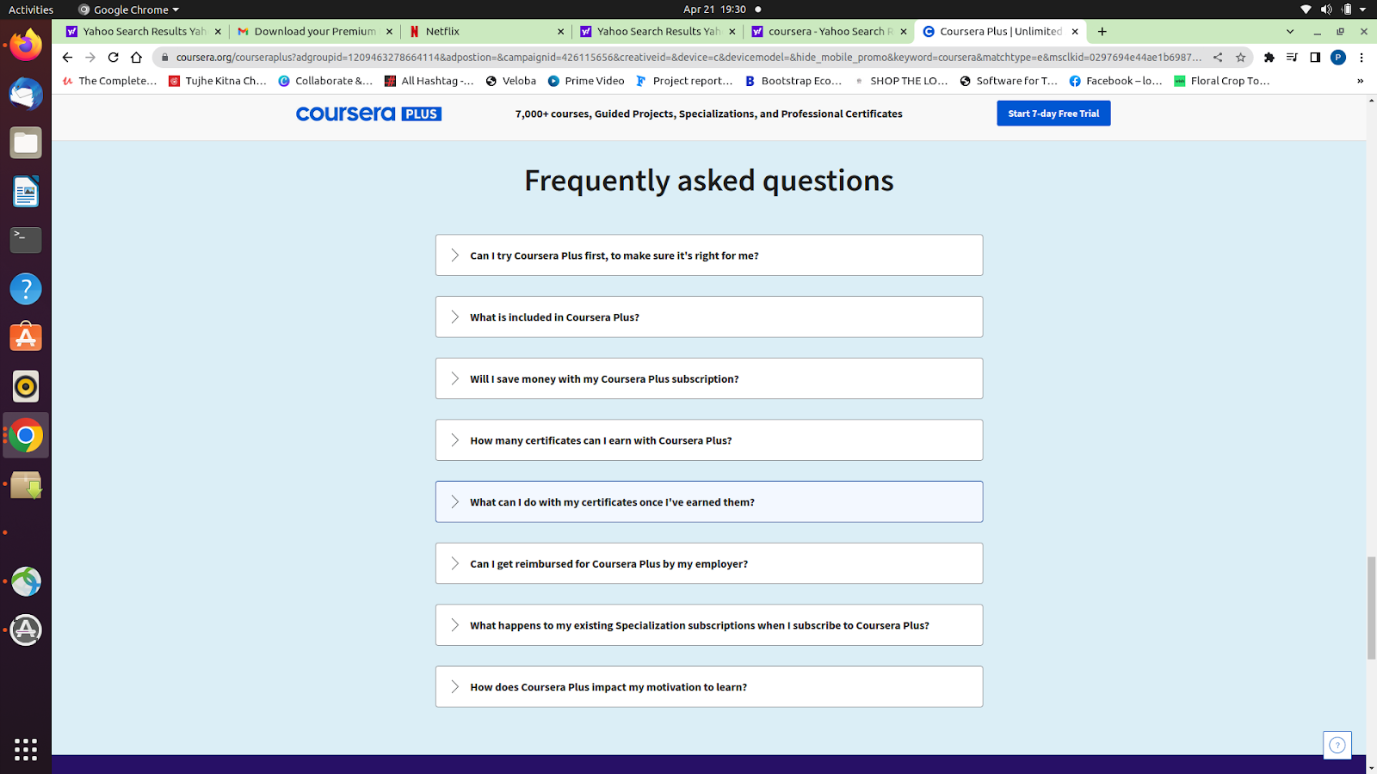

* Not being able to remove this pop-up until unless we provide a certain details in Home page.

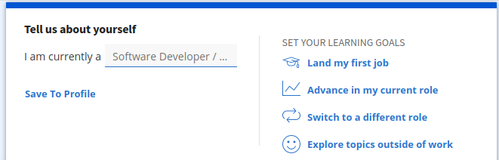

* If you paid for a course and more than 180 days have passed, you need to pay again or apply for Financial Aid. If it was a subscription, you should re-subscribe and complete the course(s).
* No assignment grading. Coursera's free courses don't include instructor or peer-to-peer grading options
* Huge fluctuations in Course reviews, Some rated extremely high and some rated extremely poor.

**5) Wow Features :**

* Coursera Plus Plans

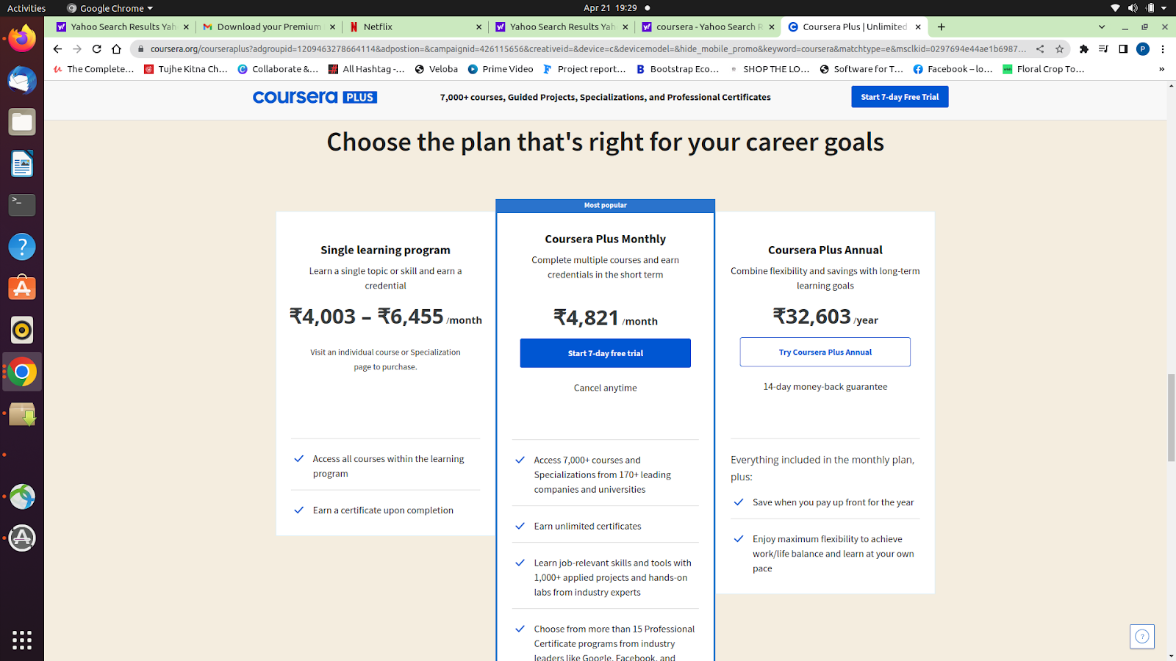

* Course Explorer search 🔍

When Cursor is on search text box

* Shows recently viewed course
* It recommends most popular or top course

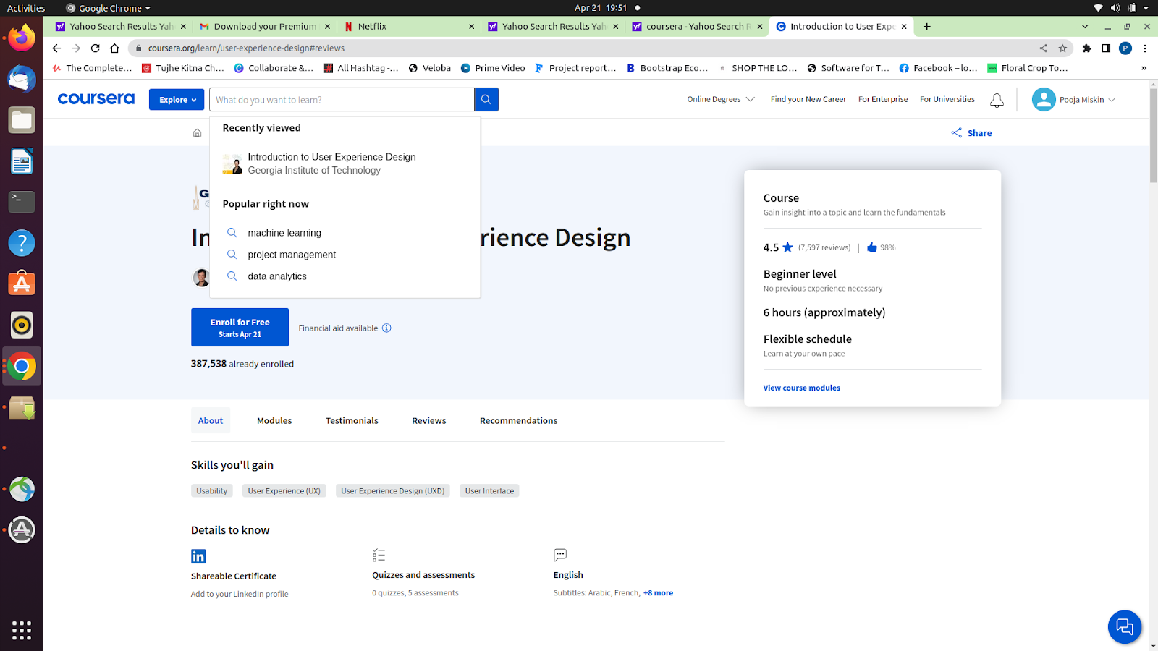

* Great Profile UI

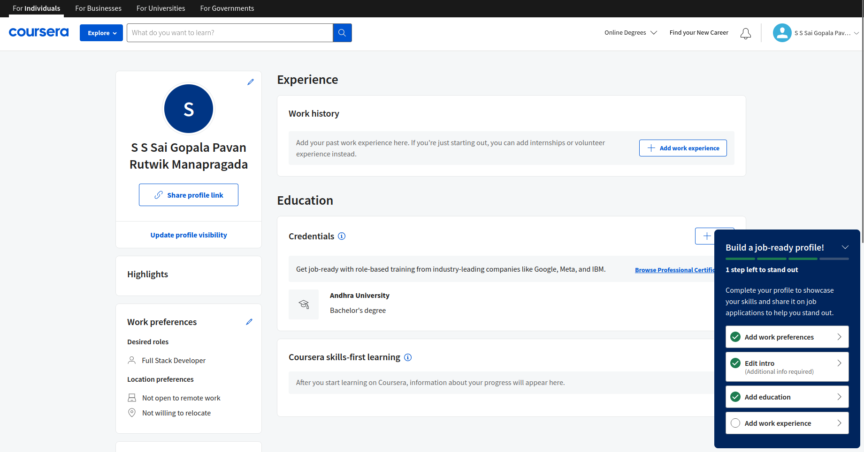

**6) Suggestions :**

* Can Provide a Little more features for Free Courses.
* Can include Topic wise quizes/Assignments for a Course.

**Teachable**

**Teachable :**

Teachable (formerly "Fedora") is a for-profit educational technology company based in New York that offers a social online learning platform designed to deliver massive open online courses (MOOCs).

People who want to teach courses on Teachable can use the service to free, or sign up for a paid plan to use additional pedagogical and e-commerce tools.

History :

In October 2014, Fedora raised a $1 million venture round. In February 2015, Fedora raised a $2 million seed round with notable investors Learn Capital, AngelList founder Naval Ravikant, Atlas Venture and Accomplice.

In September 2015, Ankur Nagpul proposed in a blog post to the Teachable community, a change in name was needed, "Our company began to need a name. A name that reflected our customers and our internal convictions. A name that reflected us all," The following month in October 2015, Fedora announced a decision to rebrand the company as "Teachable".

In May 2016, Teachable raised a $2.5 million series seed round of funding for further expansion. In January 2017, Teachable raised a $4 million Series A round.

**Task :**

**1) Features It Supports**

* Login/signup–Single sign on (SSO) to teachable blog, course builder and other related platforms

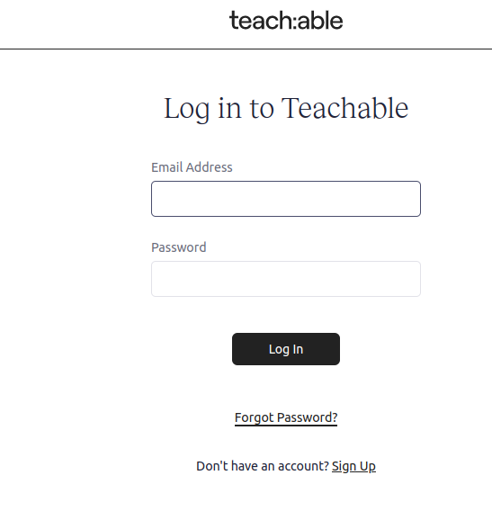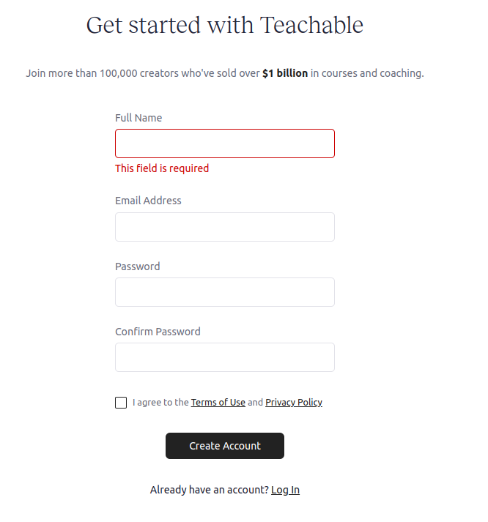

* Blog- daily blogs related to trending topics

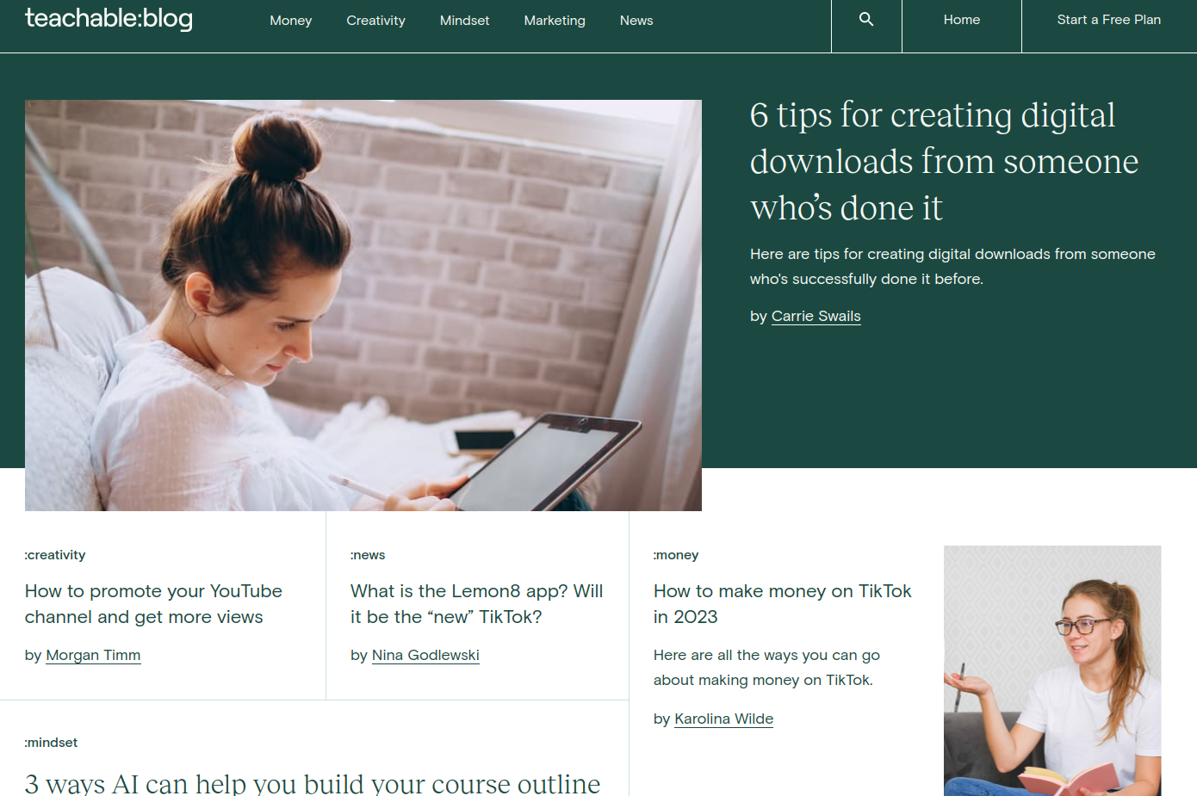

* Podcast- users can subscribe to podcast and listen on preferred streaming sites apple/spotify

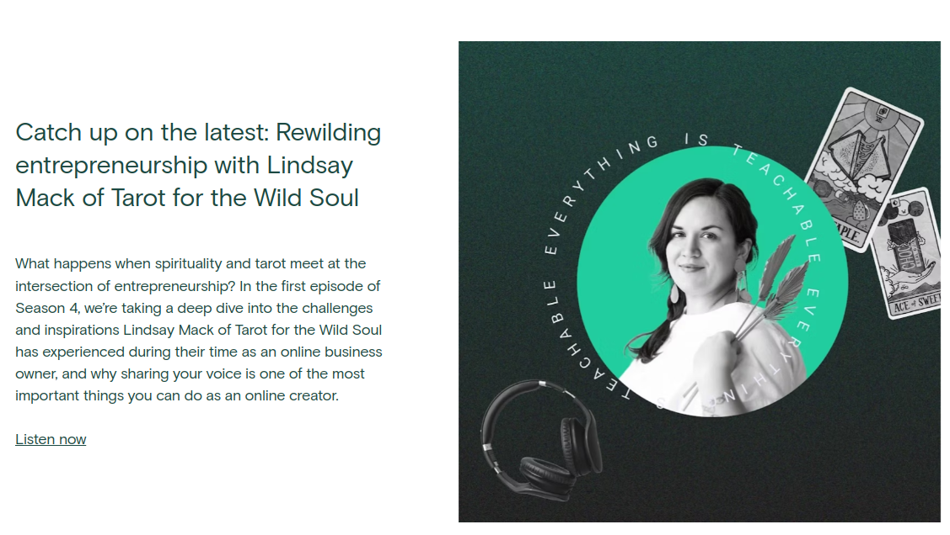

* Community-connect you with other dedicated creators running a business on Teachable

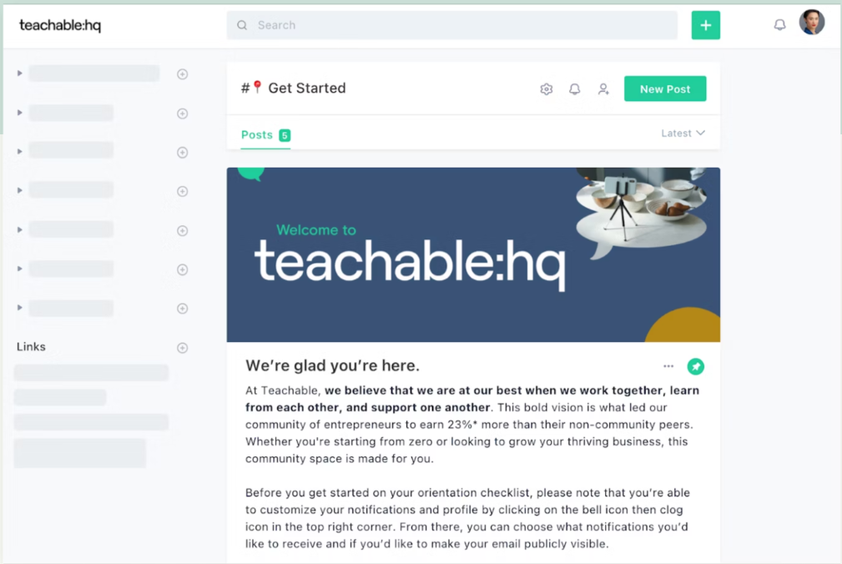

* **Ways to publish and sell courses on platform**

1. Digital download-Upload a file, set a price, and post your content instantly.

Sell PDFs, audio clips, and more



1. Online courses-intuitive course builder gives allows you to build intuitive courses. No coding or design skills necessary.
2. Coaching products-one to one expert coaching to students. Coaching offerings in different ways—hourly, time-based, or via a membership.

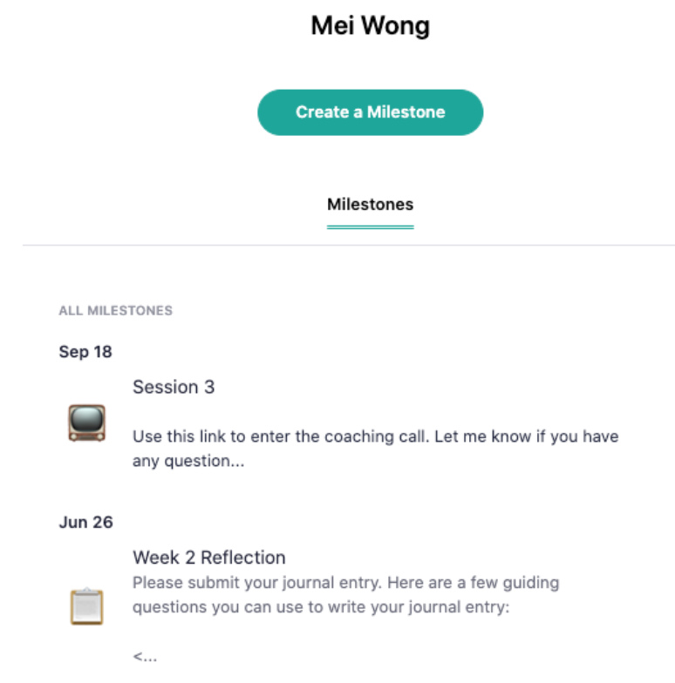

* Pricing Models

Three different models

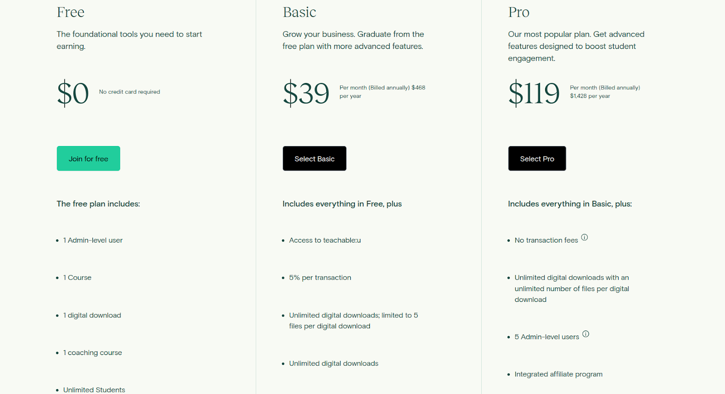

**2) Try It Out Free Login Compatible :**

A free plan on Teachable allows you to start growing your business by selling online knowledge products—not just courses, but online coaching and digital downloads too. It provide access to course design templates, core student engagement tools, and more

**3) What we liked in the Platform :**

Good for content/course creators as it provide many different tools and prebuilt templates which are easy to use and very intuitive.

Most of the features are available in free plan

**4) What we didn’t liked in the Platform :**

Not very interactive for learners. Website is mainly built course creators

**5) Wow Features :**

ai-curriculum-generator-With the curriculum generator, get your course outline then start building on it right away.

The course curriculum generator incorporates AI directly into Teachable. From your course admin, enter your course title and select an author, check “Help me generate a course outline,” and enter a course description between 1–1,000 characters. Once the outline is generated, you’ll have the option to drop the outline directly into the curriculum builder and edit from there—or start again with a new course description.

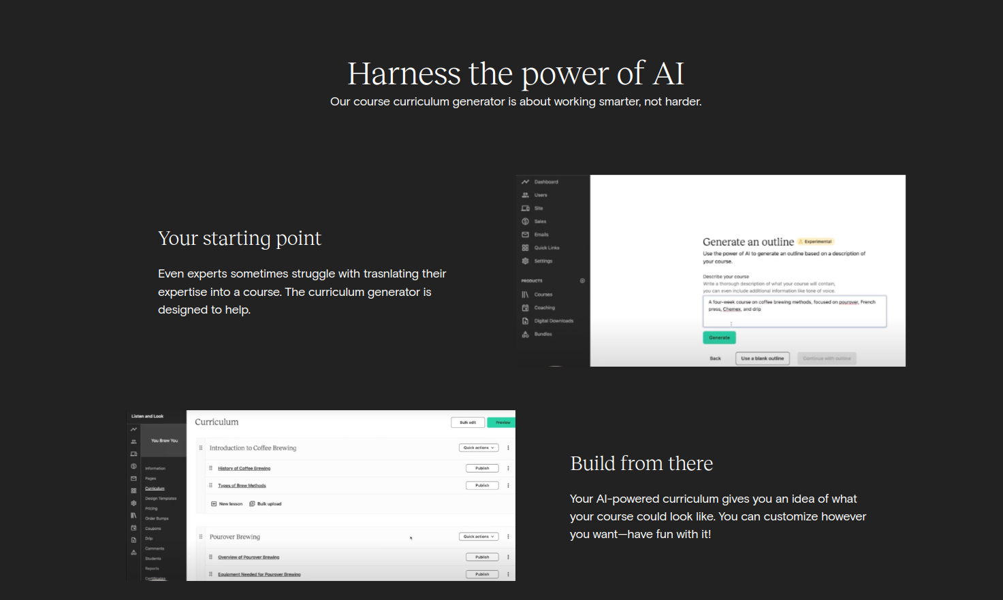

**6) Suggestions :**

**7) Types of Assesments and Assignmensts Present.:**

Mentor can create assessment and assignment via milestone builder present in webapp however there is no predefined template or feature present for them.